**Quick steps to open HDFC Salary Account**

Step I – Download the HDFC net banking application on your mobile phone (android/iOS)

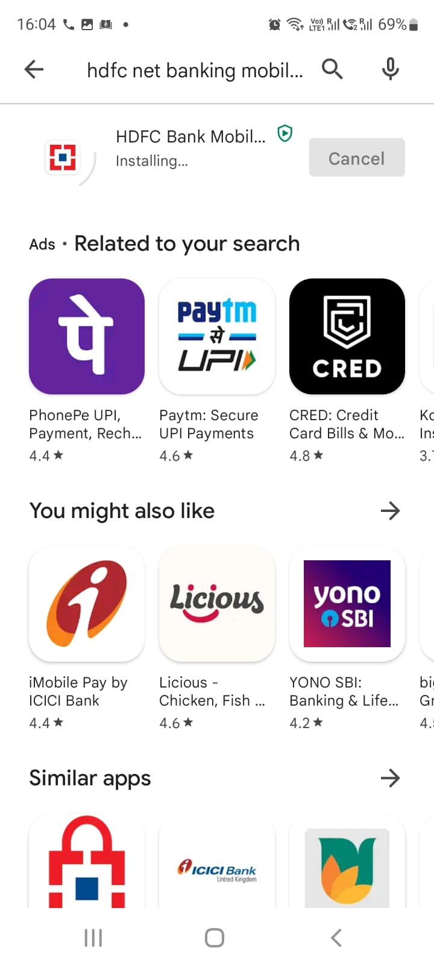

Step II : Open the application and click on *Open Account*  
  
 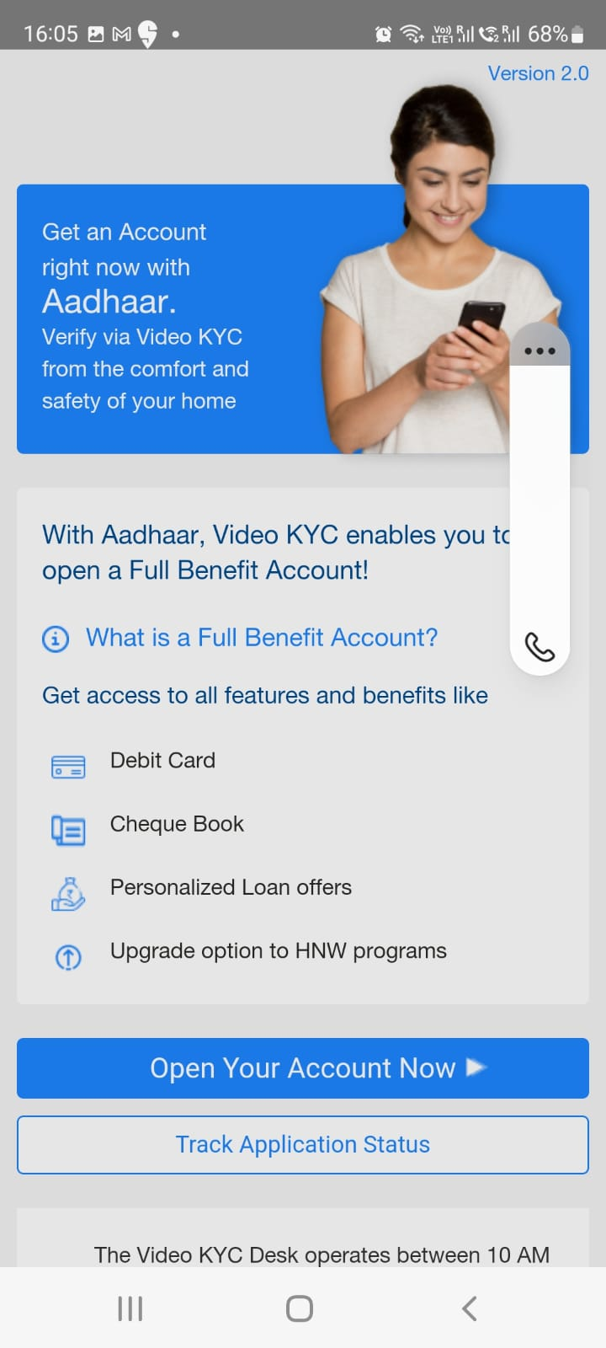

Step III: Once you click on open your account now, it will ask you to write your mobile number and then enter OTP -  
  
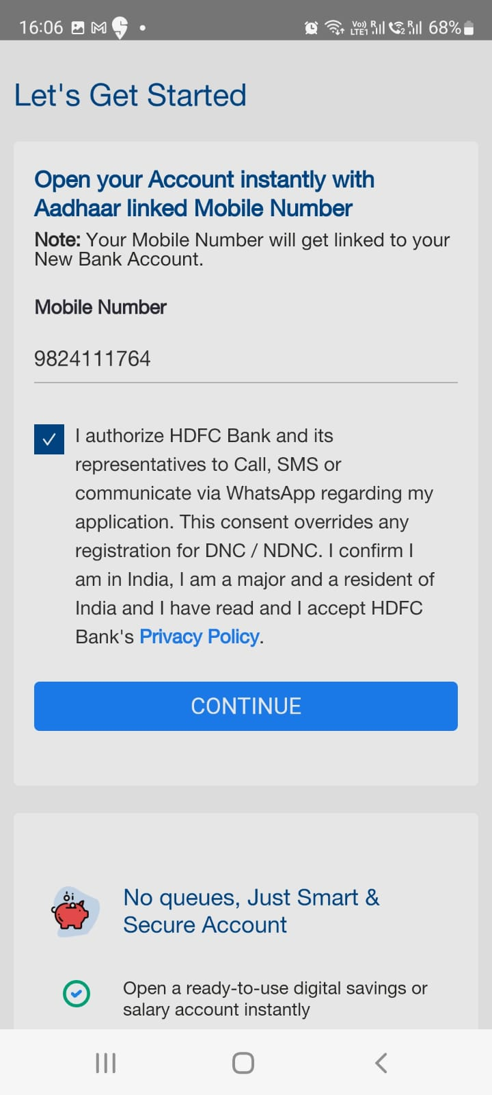 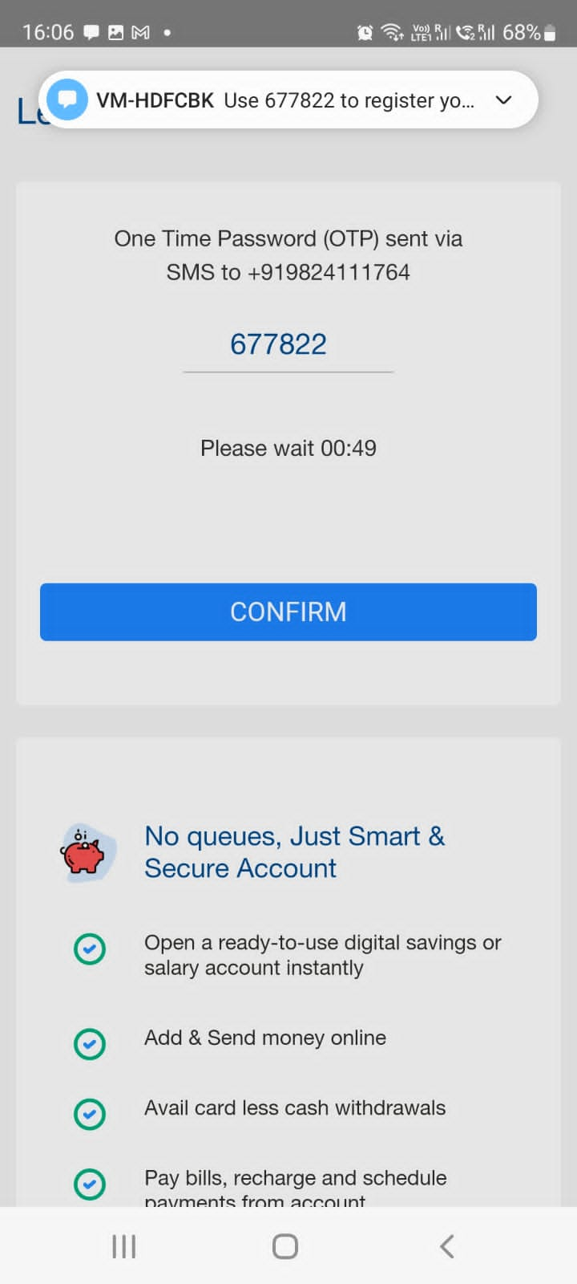

Step IV: Select your Account type – Corporate & your nearest branch along with State & City name.

Kindly select employer name – Incubyte Consulting LLP  
Note : Make sure to select ( Employer name, City, State & Branch) from dropdown only else it will not proceed ahead.  
  
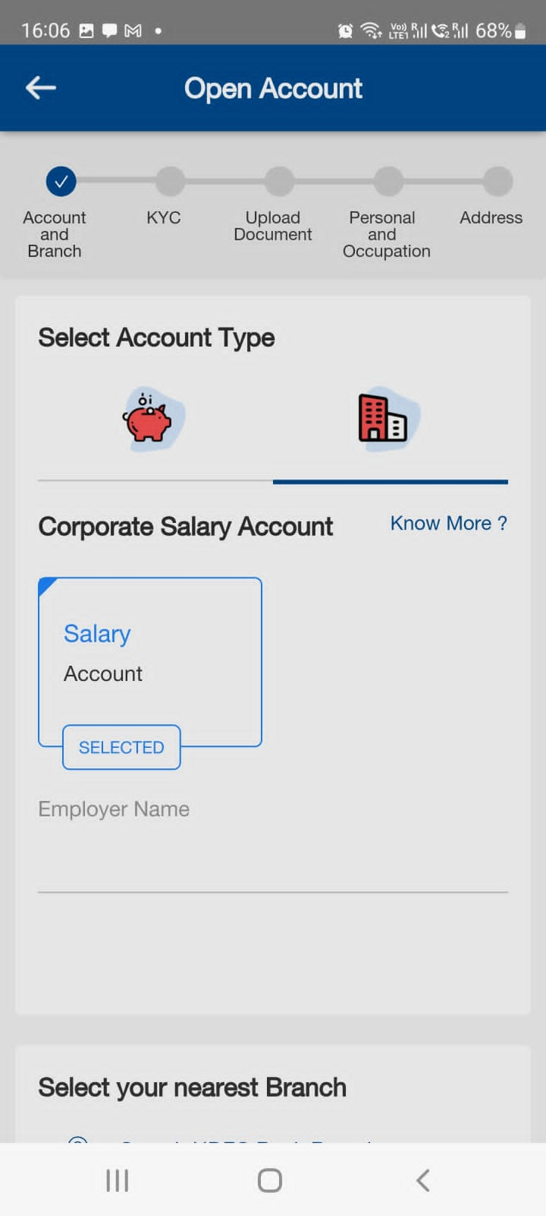 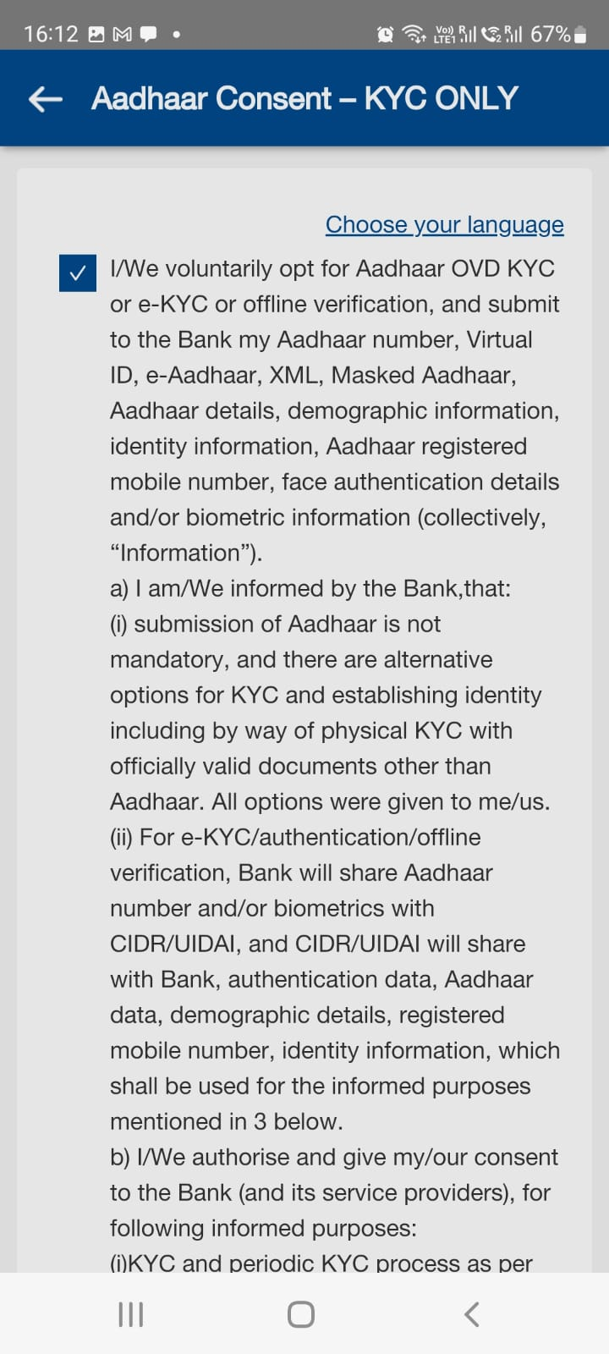

Step IV – Complete your KYC & Upload documents. Select Aadhar Card for easy & quick process.

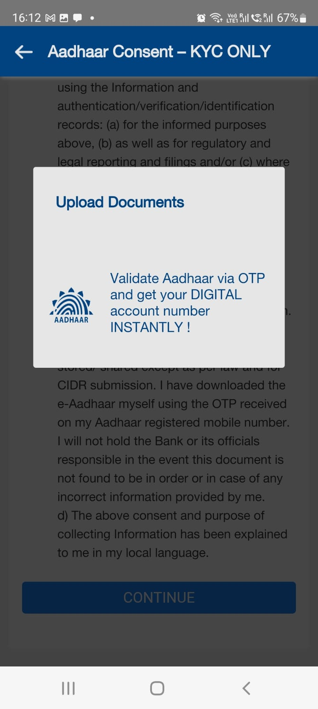

Step V: Click your live selfie & upload. Complete your Personal & Occupational details to proceed to the next steps

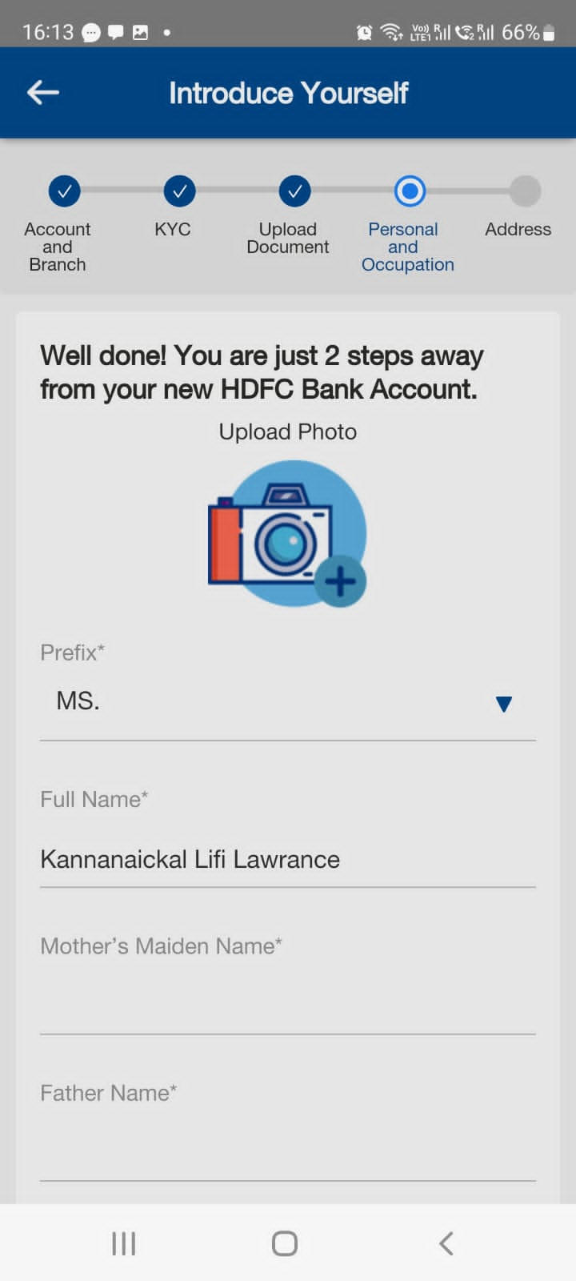

Step VI: Occupational details   
Souce of fund – Salaried

Type - Salaried

Amount – write your monthly salary

Company type – LLP

Both the Codes – 9422M

Note: Kindly mention your address as same as your Aadhar Card as it will not proceed ahead.  
Your bank welcome kit will be delivered to your Aadhar card address.

Keep your Aadhar Card & PAN Card handy while filling up the form.  
If Married, keep your spouse's Aadhar Card & PAN Card handy.

After completing all the details, you will receive a pop-up with your new account number. Take a screenshot of that for future reference.

Step VII: Complete your Video KYCC  
Once you click on request call for video KYC, you will receive a call within 5 mins from the bank representative.

Points to be noted: Keep your Aadhar Card, PAN Card, blank paper & pen with you at the time of the Video KYC.  
  
  
Congratulations, you have successfully created your HDFC salary account.